User Testing (Results)

Semester 6 – Advanced Media

Group 5 – Uplifting Union

1-6-2023

Inhoud

Introduction 4

Research question 4

Goal and Approach 4

User testing 5

Introduction for testing 5

Screen 1 6

On this screen, what immediately draws your attention? 6

Would you look at the screen if it was present at your work? 6

On a scale from 1-10, how would you rate the design and layout of this screen? 6

Do you feel that the content on this screen fosters a sense of recognition?" 6

On a scale from 1-10, how much do you think the content on this screen promotes a sense of recognition and appreciation? 6

If you could change anything for this screen, what would you change? 6

Screen 2 7

On this screen, what immediately draws your attention? 7

Would you look at the screen if it was present at your work? 7

On a scale from 1-10, how would you rate the design and layout of this screen? 7

On a scale from 1-10, how much do you think the content on this screen promotes a sense of recognition and appreciation? 7

If you could change anything for this screen, what would you change? 7

Screen 3 8

On this screen, what immediately draws your attention? 8

Would you look at the screen if it was present at your work? 8

On a scale from 1-10, how would you rate the design and layout of this screen? 8

On a scale from 1-10, how much do you think the content on this screen promotes a sense of recognition and appreciation? 8

If you could change anything for this screen, what would you change? 8

Screen 4 9

On screen 1, what immediately draws your attention? 9

On screen 2, what immediately draws your attention? 9

Would you look at these screens if it was present at your work? 9

On a scale from 1-10, how would you rate the design and layout of these screen 1? 9

On a scale from 1-10, how would you rate the design and layout of these screen 2? 9

On a scale from 1-10, how much do you think the content on screen 1 promotes a sense of recognition and appreciation? 10

On a scale from 1-10, how much do you think the content on screen 2 promotes a sense of recognition and appreciation? 10

If you could change anything for these screen 1, what would you change? 10

If you could change anything for these screen 2, what would you change? 10

Screen 5 11

On this screen, what immediately draws your attention? 11

Would you look at the screen if it was present at your work? 11

On a scale from 1-10, how would you rate the design and layout of this screen? 11

On a scale from 1-10, how much do you think the content on this screen promotes a sense of recognition and appreciation? 11

If you could change anything for this screen, what would you change? 11

General feedback 12

Do you have any additional feedback or suggestions related to the screens or the overall testing experience? 12

Based on your overall experience with the screens, what other types of content or features do you think could further enhance recognition and engagement at SIMAC? 12

Conclusion 13

# Introduction

In this file we are going to be testing the designs we made for the project for SIMAC. We have made a number of designs for the narrowcasting project, and have filtered the most fitting ones based on our style research and Simac's brand style guide. However, in order to verify the legitimacy of these choices, we are going to test the screens with users.

# Research question

Does the narrowcasting design help to stimulate recognition in Simac's workforce?

# Goal and Approach

Firstly, we want to A/B test some of the designs we made. Currently, we chose what we thought would be the best design screens, we want to verify this with users.

Secondly, we want to test if the screens do work with our goal in mind. This goal is stimulating recognition in SIMAC’s workforce, thus, do these screens stimulate recognition in SIMAC’s workforce?

We want to measure and improve aspects of the screens, such as the visual design, content placement, and other relevant factors.

# User testing

## Introduction for testing

Welcome to our user test! We would like to express our sincere gratitude for your participation in this important initiative. Your valuable feedback will greatly contribute to our project for SIMAC.

Our project revolves around addressing the research question: "How can SIMAC effectively stimulate recognition within its workforce?"

To achieve this, we have developed a solution that involves implementing narrowcasting. This entails strategically placing screens throughout SIMAC's office, displaying relevant information and data about different departments. Our aim is to create content on these screens that fosters recognition, such as expressing gratitude towards long-standing employees at SIMAC.

The screens will be displayed at a tech / IT company. You will see them more than once per day, so it's not a first glance that only matters.

Throughout this user test, we kindly request your insights and opinions on the effectiveness and impact of the displayed content. Your feedback will be instrumental in refining our approach and ensuring its successful implementation within SIMAC.

Once again, we sincerely appreciate your participation and look forward to your valuable input during this user test.

## Screen 1

### On this screen, what immediately draws your attention?

#### **User 1 (Maarten)**

I see it is a screen of an overview of a team. Rachel Smith may have a higher function than the rest because of the size of the picture. I don't know where the date stands for. Also, the date misses for Rachel Smith

#### **User 1 (Nikita)**

The thing that immediately caught my attention was the top right section that has the gradient, icons, date, and time.

#### **User 2 (Nikita)**

The pictures and the text. This caught my attention because it’s the biggest thing on the screen.

#### **User 3 (Nikita)**

The description about the person.

#### **User 1 (Vlad)**

The opening card. Liked seeing more information about the employees.

#### **User 1 (Jenny)**

The images of the people, and then the title. The middle picture is the one that caught the attention first due to being centered

User 1 (Merlijn)

Big card and the top banner thingy

**User 1 (luke)**

Big picture left

**User 2 (luke)**

Big picture on the left

### Would you look at the screen if it was present at your work?

#### **User 1 (Maarten)**

I would look, yes, mainly because of the pictures that are present.

#### **User 1 (Nikita)**

### I would look at it, but the amount of information on the screen would turn me away. So I wouldn’t bother reading all that text. If only the people’s names and occupations were there, then it wouldn’t be a problem for me, and of course, if I want to know more about them, I’ll go speak to them personally.

#### **User 2 (Nikita)**

I would maybe look at it once or twice because it’s new and it caught my attention. However, if I’m not featured, or if a friend or colleague isn’t featured, then I wouldn’t spend much time looking at it.

#### **User 3 (Nikita)**

I would because I would be curious about the people I’m working with.

#### **User 1 (Vlad)**

Would pay a lot of attention if she wanted to know more about people, especially if she was new to SIMAC.

#### **User 1 (Jenny)**

Yes, if it’s about other students like myself

User 1 (Merlijn)

At first glance no, maybe after a while.

**User 1 (luke)**

Yes, first few times, then it gets boring

**User 2 (luke)**

Only if I know them

### On a scale from 1-10, how would you rate the design and layout of this screen?

#### **User 1 (Maarten)**

7,5

#### **User 1 (Nikita)**

### I would give the design and layout of this screen an 8 because there is way too much text, so I wouldn’t give it much attention.

#### **User 2 (Nikita)**

I would rate it an 8 because I would prefer more details and colors. The grey background is a bit boring, but I think the design is perfect for an IT company.

#### **User 3 (Nikita)**

I would rate it a 10 because it’s simple, clear, and doesn’t have much text.

#### **User 1 (Vlad)**

Liked the design, but it feels like the cards are placed more towards the top and not centered. A lot of empty space at the bottom of the screen. 9.

#### **User 1 (Jenny)**

7.5, would make the images of the people stick out more. Theres a lot of text to the images, so I wouldn’t read all of it.

User 1 (Merlijn)

5.5 I can tell that its based on old design principles. Its good that is very simple, and if the goal is to follow the style guide then it looks ok.

**User 1 (luke)**

8

**User 2 (luke)**

5, it’s a little flat in terms of colours, photo’s are nice and make it personal. Could be a vacancy

### Do you feel that the content on this screen fosters a sense of recognition?

#### **User 1 (Maarten)**

Yes, the goal of the screen is clear.

#### **User 1 (Nikita)**

### Yes, it displays the team, and all there is to know about them.

#### **User 2 (Nikita)**

Yeah, I think so. When I’m walking around TQ for example, I see many faces and I only know people by their faces, but if there’s something like this then I’ll know their names, and extra information. Like this I would know more about them instead of just knowing them by their faces.

The messages on the cards are also inviting, so I would approach them.

#### **User 3 (Nikita)**

Yes, because if my picture was on the screen, I would feel like I’m part of the company. It would be something special to me.

#### **User 1 (Vlad)**

Yes, it would make employees more aware of one another especially if they’re new.

#### **User 1 (Jenny)**

Yes, it’s like a slideshow of the people so it does give sense of achievements of the people

User 1 (Merlijn)

Yup

**User 1 (luke)**

It does not promote much recognition, and will likely be interesting once and not years on end

### On a scale from 1-10, how much do you think the content on this screen promotes a sense of recognition and appreciation?

#### **User 1 (Maarten)**

7,5

#### **User 1 (Nikita)**

### I wouldn’t say appreciation is part of this screen; I see more recognition on this specific screen.

### Therefore appreciation is 0, and recognition-wise, it would be an 8.

#### **User 2 (Nikita)**

I would rate it an 8.

#### **User 3 (Nikita)**

I would say a 9 because, in general, I like when I’m recognized. For example, if there’s an event going on, instead of the organizer being “SIMAC” I would like for the company to truly show who organized the event. This way people will feel recognized for their efforts.

#### **User 1 (Vlad)**

9.

#### **User 1 (Jenny)**

7.5,

User 1 (Merlijn)

7.5 If its everywhere and visible

**User 1 (luke)**

3

**User 2 (luke)**

7, I would like it

### If you could change anything for this screen, what would you change?

#### **User 1 (Maarten)**

I wouldn't change anything, the screen is fine.

#### **User 1 (Nikita)**

The only thing I would change is the amount of text on the screen.

#### **User 2 (Nikita)**

I would make the screen more colorful and eye-catching. I personally look more at colorful things and colorful backgrounds, etc.

#### **User 3 (Nikita)**

The border radius!

#### **User 1 (Vlad)**

Didn’t understand what the dates mean, when the cards were made? Would also have the same information from the closed cards be on the open card, since it didn’t have the date.

#### **User 1 (Jenny)**

Recognition part is okay, but for appreciation part I want to see some throphies or highlight achievements of what they did (in a more graphical way). Whats the cool thing about it?

User 1 (Merlijn)

Hard to tell since she hasn’t been in the project and doesn’t know the brand guide.

**User 1 (luke)**

Gradient top right, usefulness questionable

**User 2 (luke)**

A little more ‘liveliness’ / colours, background is a bit grey

## Screen 2

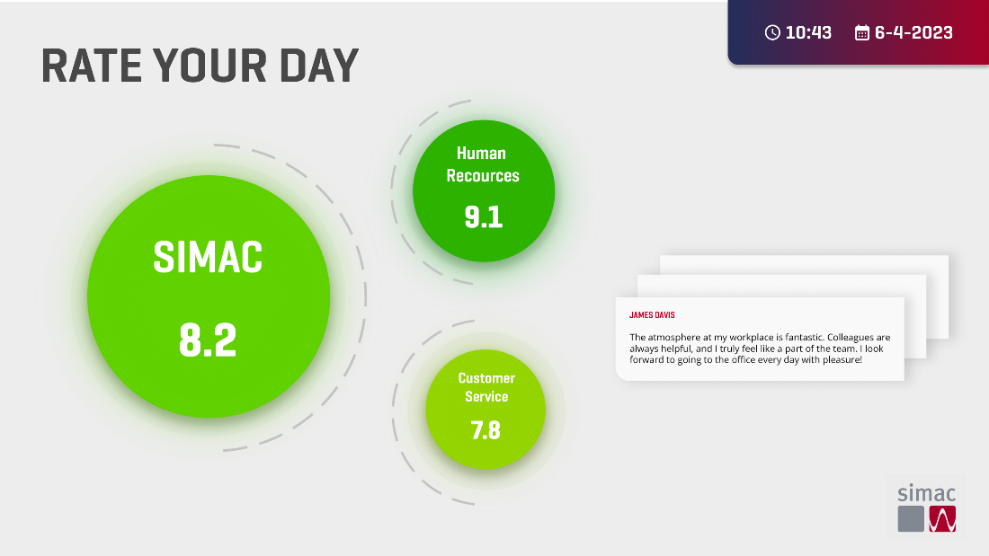

### On this screen, what immediately draws your attention?

#### **User 1 (Maarten)**

I see some ratings, which could be for some different platforms/departments. It's a screen for receiving feedback. It's clear that the numbers are an average of the ratings of the day.

#### **User 1 (Nikita)**

The big green circle that has the word “SIMAC” in it.

#### **User 2 (Nikita)**

The big green dots.

#### **User 3 (Nikita)**

The title

#### **User 1 (Vlad)**

The main SIMAC circle. The title after that and then the comments. Not sure if people would be comfortable about sharing their opinion if it’s negative. Could remove the names if they don’t.

#### **User 1 (Jenny)**

The green circles, and the comments that are a lot of text

User 1 (Merlijn)

Simac 8.2, the colour neon green.

**User 1 (luke)**

Green elements

**User 2 (luke)**

The 8.2 big bubble, it is the most noticable because of colour and font. It is more lively than the last one

### Would you look at the screen if it was present at your work?

#### **User 1 (Maarten)**

I would mainly look at the text to see what people are saying.

#### **User 1 (Nikita)**

Yes, I would because the bright colors really draw my attention.

#### **User 2 (Nikita)**

I would because I would be interesting to see what people said about their day.

#### **User 3 (Nikita)**

I would look at the screen to see the numbers change.

#### **User 1 (Vlad)**

Yes, would skim it, easy to understand and look very fast at it. Later on it would just become part of the wall though since it’s so easy to read.

#### **User 1 (Jenny)**

Definitely, it looks like it’s giving statistics. The circles are also green and big so it draws a lot of attention

User 1 (Merlijn)

Yes because I personally like neon green.

**User 1 (luke)**

When I see rate your day I would not look at it anymore

**User 2 (luke)**

Yes, mainly because it draws more attention

### On a scale from 1-10, how would you rate the design and layout of this screen?

#### **User 1 (Maarten)**

8

#### **User 1 (Nikita)**

I would rate this an 8 because the text on the right side is too small, and the light green circle’s text is difficult to see. I think on a TV screen, it might be challenging to read.

#### **User 2 (Nikita)**

I would rate it a 9 because it has bright colors and a very simple design. I like how the dots and the comments cards are separated. I would maybe make the comment cards a bit bigger because if it was presented on a big screen then the text would be too small.

#### **User 3 (Nikita)**

I would rate it an 8. I like it and it’s nice.

#### **User 1 (Vlad)**

8. Clean and easy to understand.

#### **User 1 (Jenny)**

8, text of the comments is too small, and I need to really focus to recognize it as a comment

User 1 (Merlijn)

Solid 7. Very simpel and clear.

**User 1 (luke)**

6, not sure why the icons are different sizes. The cards are kind of confusing, it’s almost like browser tabs

**User 2 (luke)**

6

### On a scale from 1-10, how much do you think the content on this screen promotes a sense of recognition and appreciation?

#### **User 1 (Maarten)**

7, I think the icons give information (numbers), but I don't know how valuable they would be for anyone. I think the text gives more impact.

#### **User 1 (Nikita)**

I would give it a 7.

#### **User 2 (Nikita)**

I would rate it a 9. I would say to maybe consider an option for anonymous rating and commenting because not everyone would want their name to be displayed on the screen with a slightly negative comment.

#### **User 3 (Nikita)**

After I got an explanation about the screen, I would say a 10 because it’s motivating for some reason.

#### **User 1 (Vlad)**

It shows how people are feeling and their appreciation of the company. A look on how they see the company. If recognition also covers how people feel then it is a 9.

#### **User 1 (Jenny)**

9

User 1 (Merlijn)

6.5

**User 1 (luke)**

3, I don’t think it’s needed for a team. It might cause confusion and hinder progress. If I’m messing up an assignment it could influence the grade, so it would make happy people happier and less happy people less happy. It might make your day worse if you have a bad day but the grade is really high.

**User 2 (luke)**

6, lack of pictures makes it less personal

### If you could change anything for this screen, what would you change?

#### **User 1 (Maarten)**

Yes, I would change the title to describe your day, and then give the circles a subtitle named rating of the day.

#### **User 1 (Nikita)**

Hmm, I would switch the smallest circle’s position with the cards’, and make the text on the cards a bit bigger.

#### **User 2 (Nikita)**

I would make the comment section a bit bigger, especially the text size.

#### **User 3 (Nikita)**

Nothing. It’s pretty clear to me.

#### **User 1 (Vlad)**

Didn’t understand if the circles would show everyone’s opinion at first or just the person shown at the right. Or if the comments scroll through. Not feeling as good about showing a specific person’s feelings. Could change title to Day ratings since “Rate your Day” feels more like a suggestion to complete a survey than showing its results.

#### **User 1 (Jenny)**

Some sort of indication that it displays information dynamically

User 1 (Merlijn)

Change the colours, but its not that necessary

**User 1 (luke)**

The 3 tabs

**User 2 (luke)**

Have something more personal (cards did not draw attention at all)

## Screen 3

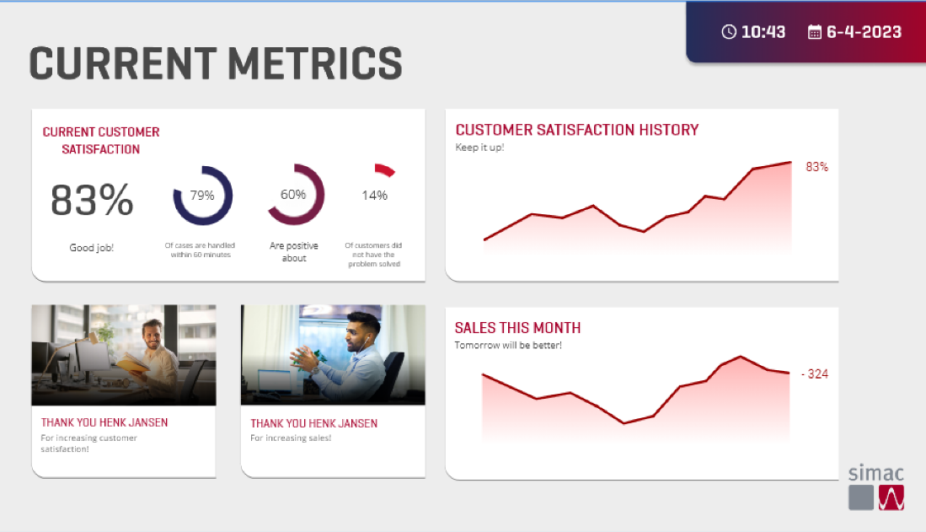

### On this screen, what immediately draws your attention?

#### **User 1 (Maarten)**

It shows a lot of statistics, kind of looks like an admin panel. It looks like it would be useful for the people that would actually do something with these numbers.

#### **User 1 (Nikita)**

The first thing that caught my attention was the circle graphs.

#### **User 2 (Nikita)**

The graphs.

#### **User 3 (Nikita)**

The 83% and good job on the top left container.

#### **User 1 (Vlad)**

A lot of things on the screen but doesn’t feel like *too* much, started looking at the percentages. Showing company stats and people; thought they were leaving when seeing thank you on the cards.

#### **User 1 (Jenny)**

The title and the circle progress bars.

User 1 (Merlijn)

Line graphs, 83%

**User 1 (luke)**

Graphs

**User 2 (luke)**

Graphs

### Would you look at the screen if it was present at your work?

#### **User 1 (Maarten)**

Depens, if I would be working with the statistics, yes. I like the appreciation on the bottom left, but I don’t know if Ill be working with the sales. (Then I explained that the statistics will be department specific) Then I will be using the statistics.

#### **User 1 (Nikita)**

Yes, I would because of how attention grabbing it is.

#### **User 2 (Nikita)**

I would, just to know if we are doing a good job. It’s not doing much for me but maybe it will motivate me to work harder due to the “thank you” section.

#### **User 3 (Nikita)**

I would because I would be curious about the numbers and what it’s about.

#### **User 1 (Vlad)**

Pretty visual, would pay attention to it, could still add more color to good results (example: customer satisfaction).

Could also rename to something like “SIMAC in numbers” like other companies showing their metrics.

#### **User 1 (Jenny)**

It’s too much. I would only look at the graphs because there’s a lot of going on.

User 1 (Merlijn)

No, because im not that interested in metrics that way. Maybe one day I would

**User 1 (luke)**

Every now and then but not the whole time. It wouldn’t really help for me

**User 2 (luke)**

Yes, I would look more often than the first one. Person is more noticable than the previous one but less than the first. It is more lively once again, although the people are maybe too small

### On a scale from 1-10, how would you rate the design and layout of this screen?

#### **User 1 (Maarten)**

8,5

#### **User 1 (Nikita)**

I would rate it a 10 because of how simple and straight to the point it is.

#### **User 2 (Nikita)**

I would rate it a 7. It’s well structured but I feel a bit overwhelmed due to the different statistics. So, I have to spend a lot of time looking at the screen to understand what is going on, especially if I’m looking at the screen for the first time. The screen has a bit too much information.

#### **User 3 (Nikita)**

I would say a 6 because the graphs on the right side are a bit difficult the understand.

#### **User 1 (Vlad)**

8.5 because the titles and text don’t feel aligned (example: title on top left split on 2 rows).

#### **User 1 (Jenny)**

7, Its too much, and the text under the header of the bar graphs are too small

User 1 (Merlijn)

Looks like a solid dashboard, 7.

**User 1 (luke)**

6, a bit too busy. The extra cards with names are not super helpful.

**User 2 (luke)**

7, it draws more attention

### Do you feel that the content of the screen fosters a sense of recognition?

#### **User 1 (Maarten)**

Yes, mainly because of the bottom left cards, and also the subtitles under those.

**User 1 (luke)**

Not on the workforce. It does not change anything really in the company, and also not for the team.

### On a scale from 1-10, how much do you think the content on this screen promotes a sense of recognition and appreciation?

#### **User 1 (Maarten)**

8

#### **User 1 (Nikita)**

I would give it a 10 because 3/4 of the sections are for recognizing what went well and the remaining section is for appreciation, which is nice to see.

#### **User 2 (Nikita)**

I would rate it an 8 because it’s not that personal. All you see is a general idea of how the company is doing. However, seeing how the company/team is doing is a good thing.

#### **User 3 (Nikita)**

I would say a 9.

#### **User 1 (Vlad)**

It shows appreciation at the bottom but she didn’t know why these people in particular are being mentioned instead of anyone else, other than that shows more about the company. 8.5 – 9.

#### **User 1 (Jenny)**

7

User 1 (Merlijn)

To be honest I think it would just be company recognition which doesn’t focus to much on the individual. 5

**User 1 (luke)**

2. I would mostly see who is not included even though they work hard

**User 2 (luke)**

7

### If you could change anything for this screen, what would you change?

#### **User 1 (Maarten)**

Maybe something with the statistics, make it more fun. (How would you make it more fun?) Maybe add a thank you message for the salesteam (or the team specific for that department)

#### **User 1 (Nikita)**

I wouldn’t change anything.

#### **User 2 (Nikita)**

I don’t think I would change anything. I would maybe work a bit more on the section’s background. Like focus on what people should look at first because now I’m looking at everything at once and it’s overwhelming.

The color pallete used is perfect for the information displayed.

#### **User 3 (Nikita)**

The graphs’ part on the right side. It’s not interesting to me and it’s difficult to understand.

#### **User 1 (Vlad)**

Nothing else.

#### **User 1 (Jenny)**

Make the text bigger, and make the design more minimalist

User 1 (Merlijn)

Design wise nothing, looks like a proper dashboard. But I would put the focus more on the people then the graphs.

**User 1 (luke)**

Not having the employee highlights

**User 2 (luke)**

One graph less and make the person bigger, it causes more recognition

## Screen 4

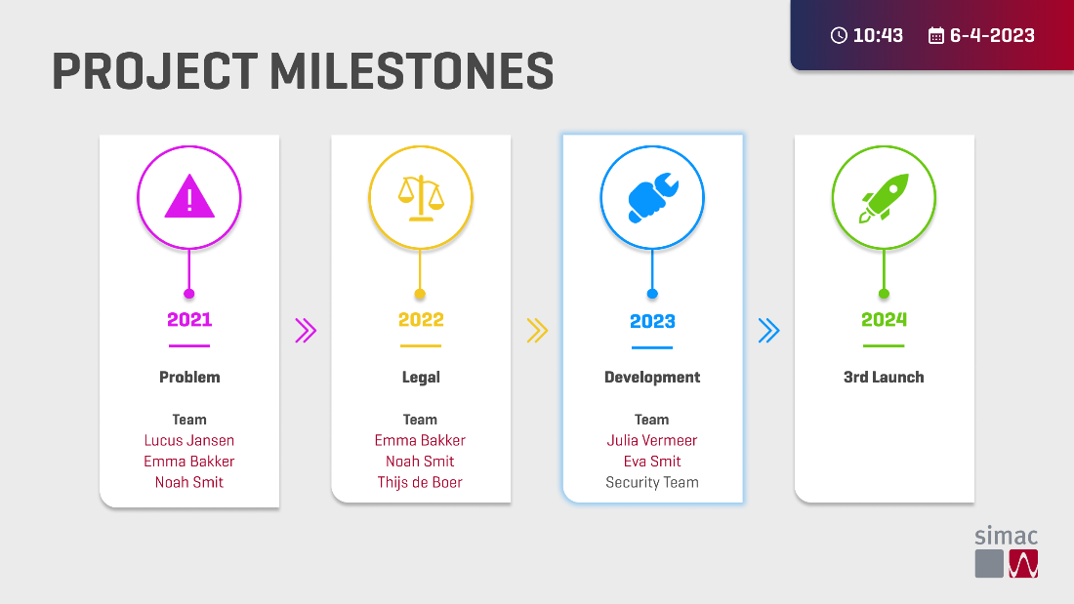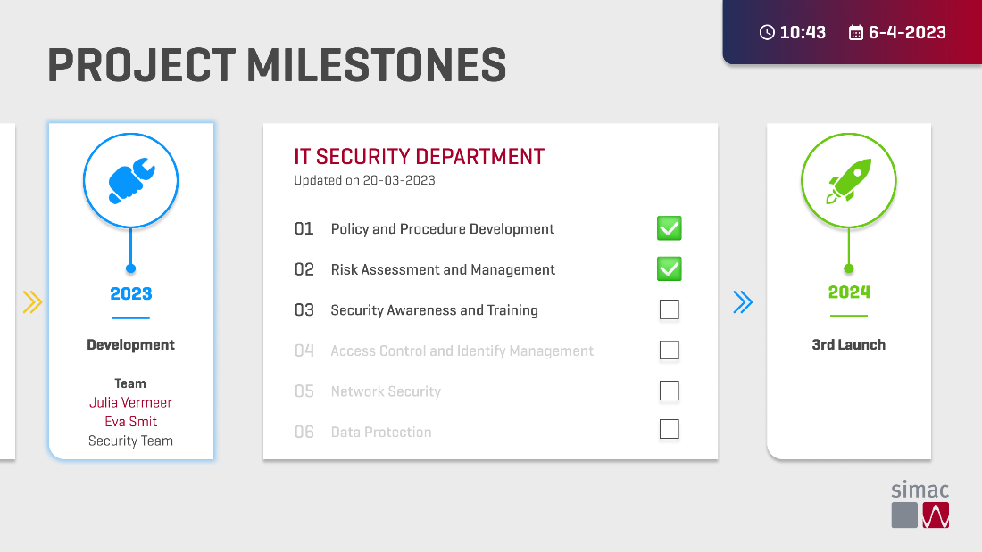

### On screen 1, what immediately draws your attention?

#### **User 1 (Maarten)**

The icons draw the most attention.

#### **User 1 (Nikita)**

The icons immediately drew my attention.

#### **User 2 (Nikita)**

The colors and the icons.

#### **User 3 (Nikita)**

The icons

#### **User 1 (Vlad)**

Doesn’t know about the project, which project? Noticed the timeline, can also see people’s contributions but doesn’t know what the project is.

#### **User 1 (Jenny)**

The icons, their colors and the huge titles

User 1 (Merlijn)

Everything basically

**User 1 (luke)**

Icons

**User 2 (luke)**

Purple icon

### On screen 2, what immediately draws your attention?

#### **User 1 (Maarten)**

The icons, then the checkboxes.

#### **User 1 (Nikita)**

The checkboxes immediately drew my attention.

#### **User 2 (Nikita)**

The sub-milestone list.

#### **User 3 (Nikita)**

The checkboxes

#### **User 1 (Vlad)**

Which department is working on the project, more information on the project and its objectives.

#### **User 1 (Jenny)**

The icons, their colors and the huge titles

User 1 (Merlijn)

The open IT SECURITY DEPARTMENT card

**User 1 (luke)**

Icons and middle screen content

**User 2 (luke)**

Blue icon left

### Would you look at these screens if it was present at your work?

#### **User 1 (Maarten)**

Maybe not the second screen, but I like the first screen, the overview of everything that needs to be done.

#### **User 1 (Nikita)**

Yes, I would because it shows me what all the team/department accomplished so far.

#### **User 2 (Nikita)**

Yes, I would if I worked on this specific team because it would give me a better understanding of where I am with the project and what still has to be done.

#### **User 3 (Nikita)**

I would because the project timeline, what still has to be done, and who is working/worked on what is very clear.

#### **User 1 (Vlad)**

She thinks so, maybe she would want to know about the project and see the stages as long as they’re not too generic and included in every project.

#### **User 1 (Jenny)**

Yes, its minimalistic and it has huge icons

User 1 (Merlijn)

### **Yes it looks inviting.**

**User 1 (luke)**

Yes. The reason I wouldn’t look at the other ones but I would in this one is that this is very business-y. It is focused on results.

**User 2 (luke)**

Yes but not as often, because there’s no names and personalization. (people’s names did not draw enough attention, it was not seen). Photos are also important for recognition. If I see someone that I saw on the screen it makes it instantly more of a conversation starter.

### On a scale from 1-10, how would you rate the design and layout of these screen 1?

#### **User 1 (Maarten)**

9

#### **User 1 (Nikita)**

I would rate it a 9 because it bothers me a bit that the “Security Team” isn’t in red as well, even though I understand why it isn’t.

#### **User 2 (Nikita)**

I would rate it a 9. The only thing that is bothering me is the 1 edge border radius.

#### **User 3 (Nikita)**

I would rate it a 10 because it’s clear, nice, minimalistic, and I like it.

#### **User 1 (Vlad)**

7, very clean, missed the information about the project though. Not sure about the names being centered, might like something like bullet points or changing the alignment.

#### **User 1 (Jenny)**

8,it’s not obvious that the development is currently active in project. Rather make the panel bigger than just highlighting it

User 1 (Merlijn)

7, Because of the older style guide

**User 1 (luke)**

8, very clear and not a lot of unnessecary stuff. Very much focused on work and the tasks. The people working on it are different colours though, reason unclear

**User 2 (luke)**

7, it is lively but the pictures are a real shame to not have

### On a scale from 1-10, how would you rate the design and layout of these screen 2?

#### **User 1 (Maarten)**

8,5

#### **User 1 (Nikita)**

I would rate it a 10 because it’s straight forward and pleasant to look at.

#### **User 2 (Nikita)**

I would rate it a 9.

#### **User 3 (Nikita)**

I would rate it a 10 because it’s clear, nice, minimalistic, and I like it.

#### **User 1 (Vlad)**

Looks a little bit boring because of all the text, would make a big difference if it had more color for the center elements instead of black (numbers, check boxes could use the same red as the title), 6.

Could also make it so the goals are closer to the milestone to better show that they are related.

#### **User 1 (Jenny)**

8, make the current active team more obvious. The connection of the tasks and current active team are also not obvious, so make a more obvious connections of those

User 1 (Merlijn)

7 Because of the older style guide

**User 1 (luke)**

8, very clear and not a lot of unnessecary stuff. Very much focused on work and the tasks. The people working on it are different colours though, reason unclear

**User 2 (luke)**

7, it is lively but the pictures are a real shame to not have

### On a scale from 1-10, how much do you think the content on screen 1 promotes a sense of recognition and appreciation?

#### **User 1 (Maarten)**

You don’t see appreciation, recognition you do. I don’t see if someone did it well, just that they worked on it. 6

#### **User 1 (Nikita)**

I would rate it a 7 because there is not much recognition and appreciation present as the previous screens.

#### **User 2 (Nikita)**

I would rate it an 8. Recognition yes because you see who the team is and the team members. However, regarding appreciation, not much.

#### **User 3 (Nikita)**

I would say a 10 because the recognition is really clear to me.

#### **User 1 (Vlad)**

If you know those people it would make more sense, if you don’t know the people and the project it doesn’t say much; make more prominent what stage they’re on, 7 if you’re in the company.

#### **User 1 (Jenny)**

7, recognition and appreciation are not obvious.

User 1 (Merlijn)

5

**User 1 (luke)**

7, because it shows what you are working on as a team. The ‘employee of the month’ stuff from the previous sections are less fitting than this one

**User 2 (luke)**

7,5

### On a scale from 1-10, how much do you think the content on screen 2 promotes a sense of recognition and appreciation?

#### **User 1 (Maarten)**

You don’t see appreciation, recognition you do. I don’t see if someone did it well, just that they worked on it. 6, it doesn’t show how someone performed.

#### **User 1 (Nikita)**

I would rate it an 8 for recognition but a 0 for appreciation.

#### **User 2 (Nikita)**

I would rate it an 8. Recognition yes but appreciation not that much.

#### **User 3 (Nikita)**

I would say a 10 because the recognition is really clear to me.

#### **User 1 (Vlad)**

Doesn’t feel personal but also not sure if you would want it; tasks could be more descriptive to better understand what it is about. Could also mention the department in the card. Gives an overview of what the people have done, could just be a matter of wording. 6 because it wasn’t clear that the tasks and the milestones were together.

#### **User 1 (Jenny)**

7, recognition and appreciation are not obvious.

User 1 (Merlijn)

5

**User 1 (luke)**

7

**User 2 (luke)**

7,5

### If you could change anything for these screen 1, what would you change?

#### **User 1 (Maarten)**

Something to give more appreciation. Maybe give the different phases stars. Give 2021 5 stars because it went well, and maybe 2023 gets 2 stars because it didn’t go as great.

#### **User 1 (Nikita)**

I would change the “Security Team” to red as well, even though I understand why it currently isn’t in red.

#### **User 2 (Nikita)**

The border radius!

#### **User 3 (Nikita)**

I would change the yellow color. The yellow is a bit less visible than the rest. You can maybe change the yellow to orange.

#### **User 1 (Vlad)**

A short overview of the other milestones could help, especially for the past ones, there’s not too much info as it is; Could also add small pictures of the people to associate them with the project better.

#### **User 1 (Jenny)**

Make it more readable and the panels bigger. Make it more obvious what the current active team is.

User 1 (Merlijn)

In both cases if your goal is to show recognition to the employees make sure you emphasize that. Now the icons take the most of the attention.

**User 1 (luke)**

Nothing needs to be changed

**User 2 (luke)**

Trying to add some personality with pictures

### If you could change anything for these screen 2, what would you change?

#### **User 1 (Maarten)**

The screen is pretty clear.

#### **User 1 (Nikita)**

Nope

#### **User 2 (Nikita)**

I would connect the development container (with the icons) to the sub-milestones container in some way. Maybe put them together in a big white container or add an arrow indicating that the 2 containers are connected.

Also, you can add maybe a timer icon or something similar to the sub-milestone the team is currently working on, instead of leaving the box empty.

#### **User 3 (Nikita)**

Nothing.

#### **User 1 (Vlad)**

Nothing else.

Not sure if “Project milestones” is a placeholder for the project name.

#### **User 1 (Jenny)**

Make the current active progress more obvious. The correlation of tasks and active progress are also not obvious, so make a more obvious connection of those

User 1 (Merlijn)

In both cases if your goal is to show recognition to the employees make sure you emphasize that. Now the icons take the most of the attention.

**User 1 (luke)**

Nothing needs to be changed

**User 2 (luke)**

Trying to add some personality with pictures

### Extra question (On screen 2, would you combine the block, or keep it seperated?)

I would combine it. Make it one big card, and put a small border in between or something like that.

## Screen 5

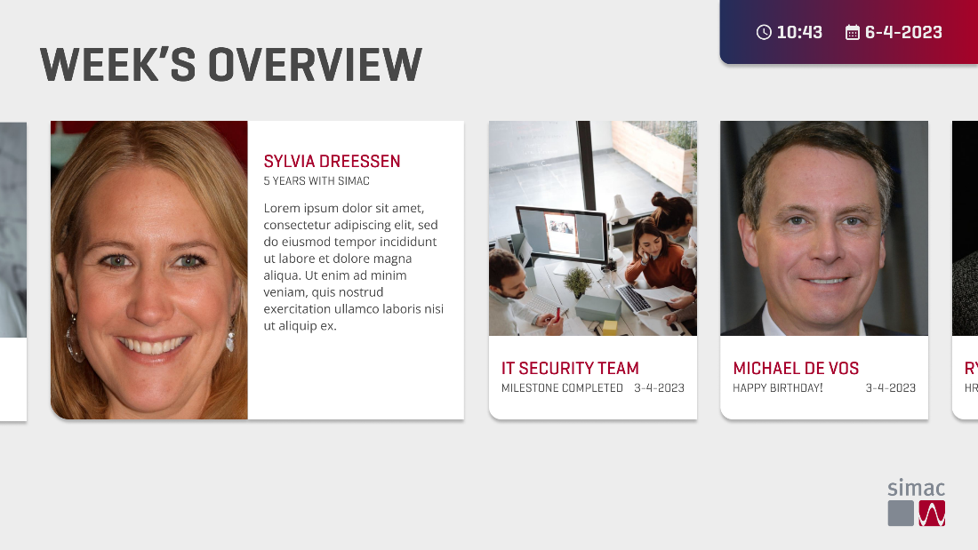

### On this screen, what immediately draws your attention?

#### **User 1 (Nikita)**

The pictures of the employees immediately drew my attention.

#### **User 2 (Nikita)**

The big images.

#### **User 3 (Nikita)**

The subtitle caught my attention, because it bothered me that it blends in with the rest of the text.

#### **User 1 (Jenny)**

The bigger photo on the left

**User 1 (luke)**

Photo’s

**User 2 (luke)**

Biggest picture

### Would you look at the screen if it was present at your work?

#### **User 1 (Maarten)**

Yes, they had something like this at my intern company.

#### **User 1 (Nikita)**

I would because the photos caught my attention, but I wouldn’t read all the text.

#### **User 2 (Nikita)**

I would. Maybe even more than the first screen, because the content changes every week and I like that I can see birthdays, milestone completions, etc.

#### **User 3 (Nikita)**

I would.

#### **User 1 (Jenny)**

Yes, if its about other students

**User 1 (luke)**

Yes because it is focused on the company work instead of the team. It should be throughout the whole company

**User 2 (luke)**

Yes, I would look at this more than once

### On a scale from 1-10, how would you rate the design and layout of this screen?

#### **User 1 (Nikita)**

I would give the design and layout of this screen an 8 because there is way too much text and due to this I wouldn’t give it much attention.

#### **User 2 (Nikita)**

I would rate it a 9. I would maybe add a bit more color somewhere, maybe in the background or on a specific card or something. By Michael, for example, you can add an emoji or a cake or something to make it more eye-catching.

#### **User 3 (Nikita)**

I would rate it an 8 because the subtitles don’t stand out.

#### **User 1 (Jenny)**

7.5, would make the images of the people stick out more. There’s a lot of text next to the images, so wouldn’t read all of it.

**User 1 (luke)**

7. Very clear, I would look at this the most out of all screens. It is a bit more messy though, the second picture makes it messy

**User 2 (luke)**

6.5

### On a scale from 1-10, how much do you think the content on this screen promotes a sense of recognition and appreciation?

#### **User 1 (Maarten)**

8,5

#### **User 1 (Nikita)**

I would say 0 on appreciation and 8 on recognition.

#### **User 2 (Nikita)**

I would rate it a 10 because it doesn’t only show the images of the people on the team. The subtitles on the screen is very personal and it shows that the company knows you and appreciates you.

#### **User 3 (Nikita)**

I would say a 10 because if my picture and description were there then I would feel very special.

#### **User 1 (Jenny)**

7.5, its like a slideshow of people so it does give sense of achievements of the people

**User 1 (luke)**

7,5 if it is applied on the whole company. It is focused on milestones more than the first few ones. Those would probably not be looked at much

**User 2 (luke)**

7.5

### If you could change anything for this screen, what would you change?

#### **User 1 (Maarten)**

Maybe it’s a fun idea to give the one that has his birthday a party hat.

#### **User 1 (Nikita)**

Hmm, I would say make the overall idea of the screen more clear because I don’t understand what this screen is supposed to be.

#### **User 2 (Nikita)**

I would add more eye-catching details. I would maybe change something in the background, add colors, icons, some more graphical stuff, etc.

#### **User 3 (Nikita)**

I would change the subtitle color to make it known that it’s something special. It currently blends in with everything else.

#### **User 1 (Jenny)**

Recognition part is okay, but for appreciation part. Want to see some trophies or highlight achievements of what they did (in a more graphical way). What’s the cool thing about it.

**User 1 (luke)**

The pictures, they aren’t consistent

**User 2 (luke)**

Make it more lively

## General feedback

### Do you have any additional feedback or suggestions related to the screens or the overall testing experience?

#### **User 1 (Maarten)**

No, it was good.

#### **User 1 (Nikita)**

Nope

#### **User 2 (Nikita)**

I think the product you guys made is very good and close to what SIMAC would like. I don’t think I would add anything to it. The product is very good, professional and interesting to add to the company.

#### **User 3 (Nikita)**

Nope.  
It’s really clear, I like the screens and I would definitely look at them.

#### **User 1 (Vlad)**

Just look at wording and spacing, design seems to follow visual guidelines as it is, give more information to make it feel more personal.

**User 1 (luke)**

The idea is not from the workforce, because it is based on team engagement and stuff which does not work in practice.

**User 2 (luke)**

A lot of screen are kind of bland and don’t draw enough attention. Numbers are not very easy to judge for these screens but descriptions work better

### Based on your overall experience with the screens, what other types of content or features do you think could further enhance recognition and engagement at SIMAC?

#### **User 1 (Maarten)**

Not that I can think of currently.

#### **User 1 (Nikita)**

I would say maybe implement a screen for company events. It doesn’t stimulate recognition, but I think it stimulates engagement.

#### **User 2 (Nikita)**

I don’t think so.

#### **User 3 (Nikita)**

Nope

#### **User 1 (Vlad)**

If they are doing any workshops together it would be good to mention, if they do them. Different grouping of faces of company per function or per team.

**User 1 (luke)**

The last two, the milestones part, is the best way to improve recognition.

**User 2 (luke)**

Personal experience instead of ‘business-y’

# Conclusion

#### **User 1 (Nikita)**

In conclusion, the participant was pleased with the design and layout of the screens. He also felt the recognition aspect through the screens, which is great to hear.  
 However, it was difficult for him to find appreciation in certain screens. Or maybe, in our project’s case, recognition and appreciation means the same thing. In that case, our goal was accomplished.

#### **User 2 (Nikita)**

In conclusion, the participant liked the overall designs and layout of the screens. As you can see by her answers, she would rather a more colorful approach, but she understands the professional usage of colors and images for an IT company.

The participant made it known that she saw the recognition that the screens are displaying, suggesting that our goal was reached.

#### **User 3 (Nikita)**

In conclusion, the participant was quite pleased with the overall designs and layout. The participant also felt a sense of recognition through the screens, concluding that our goal was reached.

#### **User 1 (Vlad)**

The participant noticed a lot of ways that recognition was being promoted, but she felt the screens could have been more personal. This would mostly be done through the text though, by writing it from the employees’ perspective. She also had some difficulties understanding some of the content at a first glance, but noticed the points of the screens quickly afterwards. Still, this would point towards needing more clarity on some of the screens, especially since they would have to be shown quite quickly.

#### **User 1 (Jenny)**

The screens could potentially help to stimulate sense of recognition and appreciation for the employees of SIMAC. Even though the screens do have something attention-grabbing like the big title and colors, most also have at least one part in the screens that has a lot going on, which could make people not pay a lot of attention to it or not look at all like the statistics screen. The feedback gathered from the user testing is:

* Explain information more graphically with icons or text.
* Make the connection between subjects more obvious
* Make the designs more minimalist